Project Development - Database design

## Intersect and Minus:

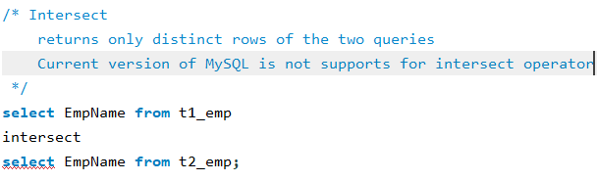

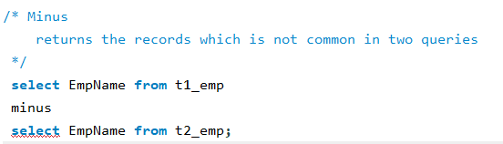

## Joins in MySQL:

1. When we require the data from more than single table
2. A relational database consists of multiple related tables together using of common column that is in generally we call it as “Foregin Key”.
3. If you're trying to apply a join based on the same column then it refers to “self-join”, It might be two table or more than two tables.

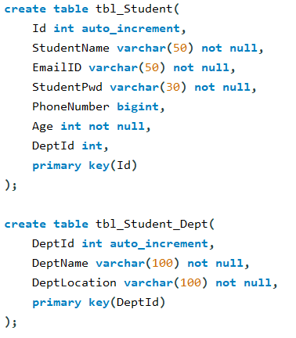

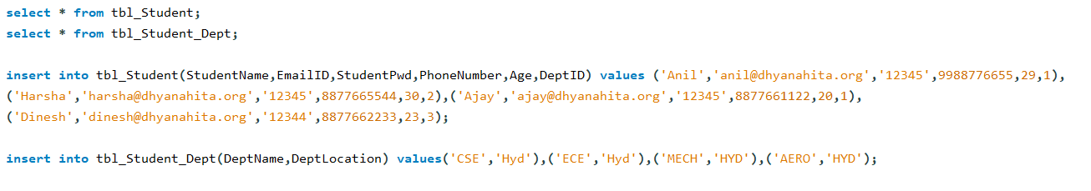

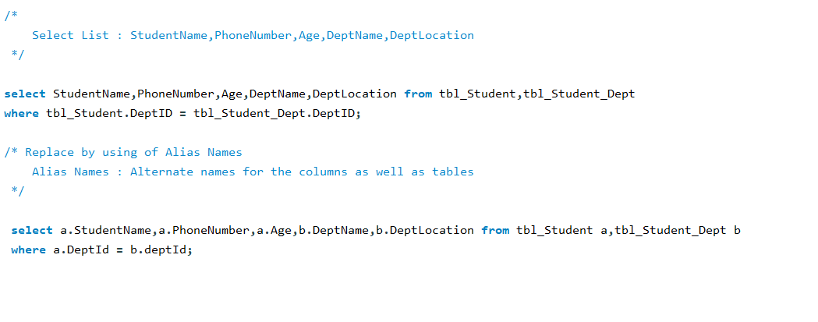

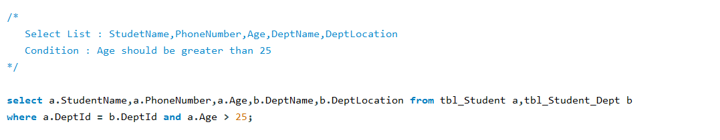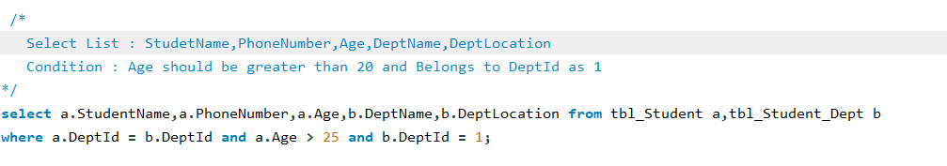

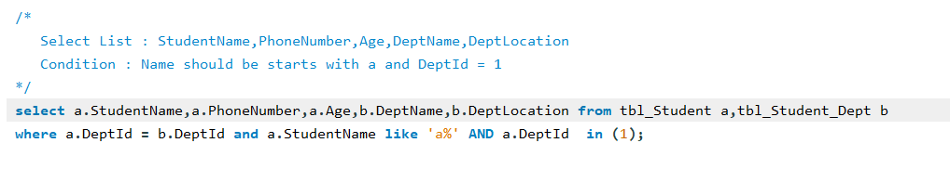

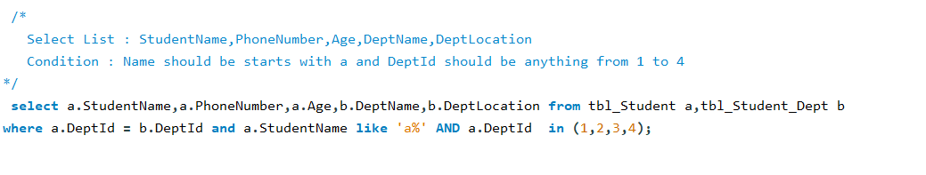

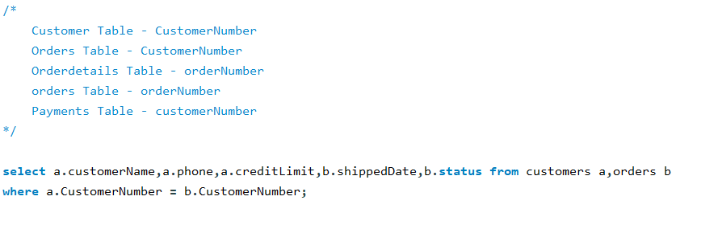

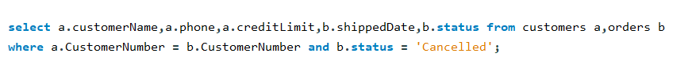

## Left Join

1. Right Join
2. Cross Join